**1) Hide your application from launcher. i.e remove category launcher from activity and and activity alias**

<activity-alias

           android:name=".ZGameActivityAlias"

           android:enabled="false" // this will hide app

           android:icon="@drawable/ic_launcher"

           android:label="@string/app_name"

           android:targetActivity=".MainActivity" >

           <intent-filter>

               <action android:name="android.intent.action.MAIN" />

               <category android:name="android.intent.category.LAUNCHER" />

           </intent-filter>

       </activity-alias>

Other application will launch your application (above) i.e launchable activity by

Intent intent = new Intent(Intent.ACTION_MAIN);

intent.setComponent(new ComponentName(packageName, packageName +".XYZ"));

startActivity(intent);

**2) signe both applications with same keytool and**

**I)  Declare permission in client application**

<permission

       android:name="com.zgame"

       android:label="my_permission"

       android:protectionLevel="signature" >

   </permission>

<activity

           android:name="com.hellowworldcustom.MainActivity"

           android:label="@string/app_name"

            android:permission="com.zgame" >

**II) In launcher add**

   <uses-permission android:name="com.testpackage.mypermission"/>

**3) Add security calls in client applications , i.e check that use has subscription**

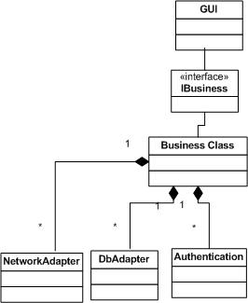  
  
  
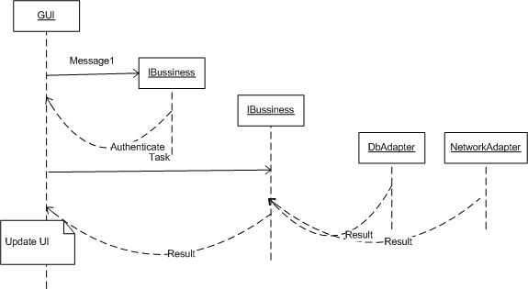

**Db:**

**Game:**

id, position (-1), title, description, category_id, create_time, update_time, downloads, uninstalls , package, apk_name,ventor_id, curr_version, icon, featured_icon

**Feature Games:**

id, game_id, position (-1)

**Category:**

id, category

**User:**

id, phone, pin

**My games:**

game_id , user_id, enable, version

**Launch analyst**

game_id , user_id, launch_date

**Vendor**

vendor_id, title

**Service response Architecture**

{

    “status” : true/false,

           “message” : “”

            “data”[

            ]

}

getAllGames => options are i.e searchby, page, last page

getFeaturedGames

getMyGames

getGameDetail

getAuthenticate

**Reference:**

**1)** [**http://stackoverflow.com/questions/8816623/how-to-use-custom-permissions-in-android**](http://stackoverflow.com/questions/8816623/how-to-use-custom-permissions-in-android)

 2) <http://developer.android.com/guide/topics/manifest/manifest-intro.html>

 3) http://stackoverflow.com/questions/20064026/how-to-visible-invisible-launcher-icon-in-android